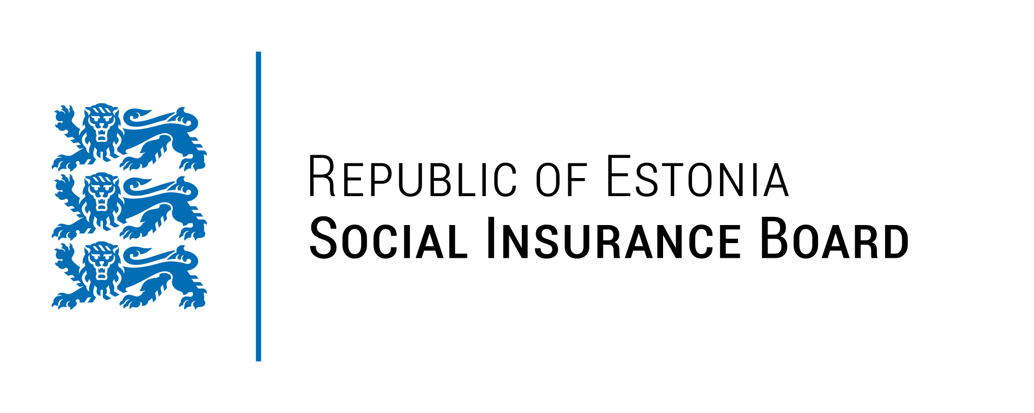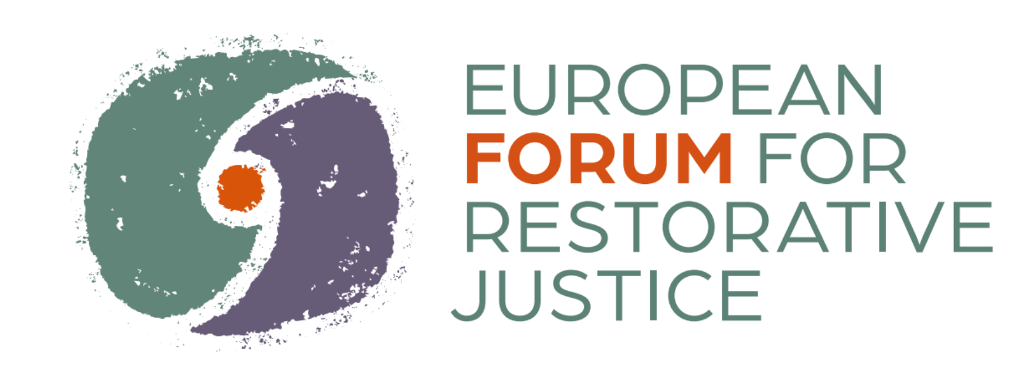

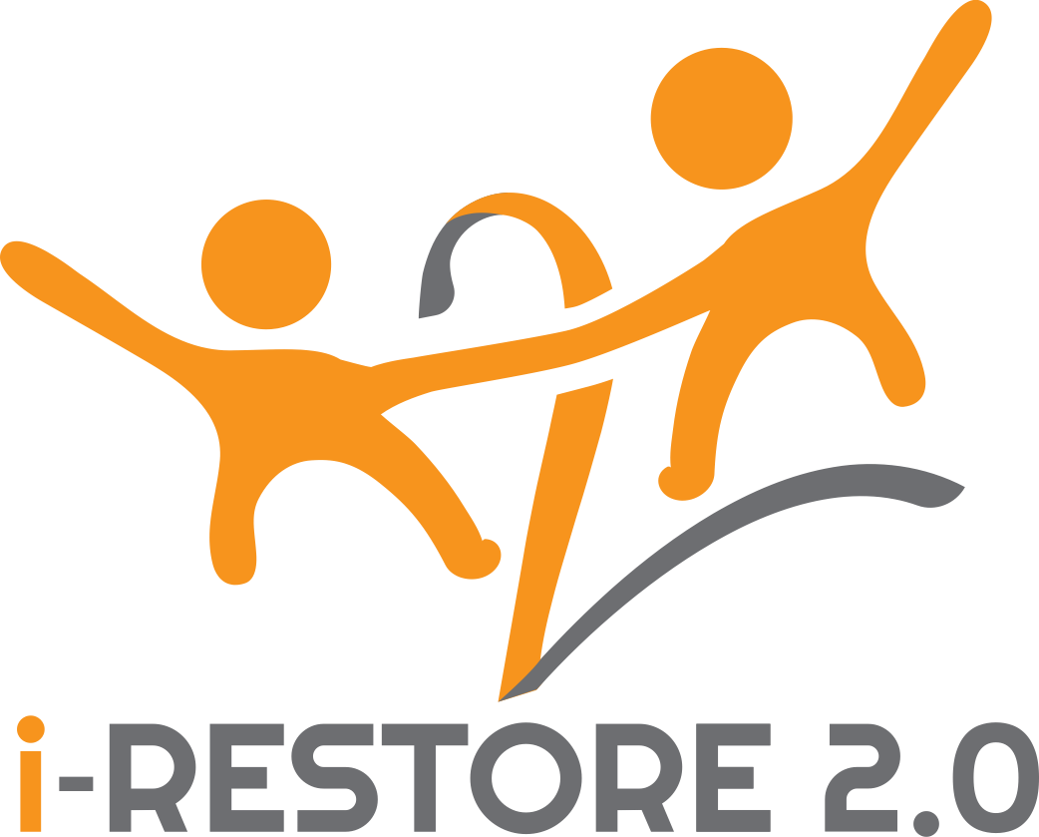

Questionnaire on Twinning Arrangement Experiences for i-RESTORE 2.0 Consortium Members

*As an additional output of i-RESTORE 2.0, a How-to Practical Guide is prepared to inspire and encourage other EU member states to implement Twinning Arrangements (TA) in restorative justice for children. The Guide is informed among others by the experiences of implementing the country's experiences, lessons learnt, and critical observations, all enriching the content upon which recommendations can be crafted.*

*Thank you for taking the time to reflect on the questions and supporting the pre**paration of the Guide!*

**Themes:**

* 1. **Your organization**
  2. **Set up and design**
  3. **Communication**
  4. **Conclusions, lessons learnt during TA**
  5. **Post-care**
  6. **Additional thoughts**

1. **Your organization**
2. Your organization’s name

Social Insurance Board of Estionia

1. Did your organization participate in a Twinning Arrangement before?

I am not sure if they have been called so, we are an organisation with over 10 departments and over 1000 employees. There have def been visits/collaborations etc between countries.

1. If yes, how many times?

Hard to say

**B. Set up and design**

1. When working on the rapid needs assessment, have you identified anything new to you in your country’s situation on restorative justice for children (for example a new perspective, a new goal defined, identifying a new silo, or defining a challenge from a different perspective…etc)?

It was interesting to hear about the specialists view on child-friendly justice. And overall the interviews conducted was a great starting point.

Well, it’s not exactly new information but lack of including children in processes. Everyone thinks that they should be involved in design etc but no action.

1. What has been the action plan that you set up according to the rapid needs assessment? It consisted of which processes, activities and events and why did you choose these? How was the following action plan designed? Was it designed according to a methodology? What aspects have you considered and found important when planning the TA?

Here’s the action plan:

It was designed after the RNA and taking into consideration what could work in Estonia and what would be interesting for the stakeholders. Although most of the activities are project deliverables.

|  |  |  |  |
| --- | --- | --- | --- |
| **ACTIVITIES SUGGESTED**  **(based on what Estonia can bring to Romania and what Romania can bring to Estonia –**  **building on above-mentioned strengths and gaps)** | | | |
| **Type of activity** | **Description of the activity (methodology)** | **Target group** | **Timeline** |
| *Webinar(s)* | Interactive join webinars with all **4 countries** are proposed on issues such as:   * + *Restorative justice and crime prevention*   Keynote Speakers: criminologists, sociologists, psychologists   * + *Restorative justice and victim protection*   Keynote speakers: criminologists, lawyer, mediators, professionals from EU institutions for victims rights   * + *Restorative justice as solution for conflict/school violence*   Keynote speakers: criminologists, sociologist, psychologists, mediators   * + *Media representation of restorative justice practice*   Keynote speakers: criminologists/sociologist, Professionals from media (TV, newspaper etc) social media, mediators  Specialists share their experiences on collaboration – best practices   1. How to involve children in decision making so they would feel involved/that their voice is heard 2. How to ask feedback from children?   Best practices on collaboration between specialists | 1. Professionals from justice system, child protection, education system 2. Professionals from justice, child protection, education systems; parents and students 3. Professionals from schools/education systems; Police (Poliția școlară/Police of School, Crime Prevention unit); students and family; parents associations, student’s association, social media groups of parents 4. Journalist and student from Faculty of Journalism, social media influencer (topics 1, 2, 3,4)   Specialists from multiple organization (police, child protection, prosecution, ministries, detention facilities, etc) | Autumn 2023 and  Spring 2024 |
| *Awareness circles* | This activity will be conducted in schools with the participation of students, teachers, parents and other specialists. The concept of restorative justice will be introduced to the participants. During the twinning meetings experiences will be shared.  The learnings from these gatherings will be gathered together into a join ‘Awareness Circle Storybook’ for **all 4 target countries**. | Students, teachers, school management, parents, representatives of victim support organisations, and other specialists. | Estonia had the first circle on 10 March 2023 and Romania had it’s first meeting on 27 February 2023. Other meetings are expted to take place in 2023 and 2024 |
| *Policy Working Groups* | One Policy Working Group will be established in each country. The group will have regular meetings and the outcomes of each session can be communicated to the twinning country to achieve better results in promoting RJ. Both Working Groups can provide feedback and comments on the **Budget Policy Brief** that will be developed. | Public prosecutors, police officers, juvenile judges, representatives from the Ministry from Ministry of Justice, Education and Social Affairs, representatives of child protection and closed childcare institutions, academics and others. | Estonia had the first meeting on 27 March 23 and Romania on 24 February 2023.  Meetings take place quarterly or more frequently if requested by the delegates. |
| *CAB Exchange* | Members of the CABs from all **4 target countries** will be interacting through the CAB trajectory in different digital/audio-visual ways (i.e. a digital meeting, ‘challenges’ or questions from one CAB to the other. This will further increase the degree of child participation and facilitate connection between the youths. | Children & Youths (CAB members) together with the facilitators involved in guiding the CABs. | September 2024 and April 2024 |
| *Study visit* | One study visit will take place in each twinning country. The professionals who will participate will have the opportunity to visit key stakeholders and services related to RJ and learn about how the legislation is actually implemented in practice. All the participants will be benefited by networking and exchange of good practices | Professionals from justice system: police, prosecutors, judges, mediators, probation counselors, lawyers, professionals from youth detention centers and National Administration of Penitentiaries  Youth from Child Advisory Board | November 2023 |
| *Newsletter(s)/themedia articles/posts* | Online Newsletters will be produced by **each team** **from the 4 target country** in the form of a short update on work done in the project and a way to create awareness – experiences, case studies, etc.  Share results from RNA, RJ testimonials, CAB activities, training activities.  International channels (e.g. EFRJ newsletter, CFJ-EN) as well as internal channels such as Social Work magazine (Estonia) and other newsletters through various listserv channels. | Specialists working with children – police, child protection, prosecution, ministries, detention centers etc. | Every 6 months |
| *Exchange of experiences/practices* | Specialists meetings – focus on one topic. For example domestic violence, sexual abuse, detention centers for children, RJ in cases with children and youth – legal framework and results on evaluation of RJ, prosecution in cases with children, policing in cases with children, court child procedures. | Specialists from multiple organization (police, child protection, prosecution, courts, mediators, child protection etc.)  Each meeting has a specific topic. | Quarterly, depending on availability |

1. What challenges can you recall occurring during the setting up of the TA? How did you find a solution for that? If retrospectively you can change something in the design, what would that be?

In the beginning it was meant that RNA about Estonia will be written by Romanian specialists, visiting Estonia and vice versa but this did not make sense and it was changed so that each country does it about their country. And based on it the TA.

But also - It was complicated due to lack of time and money. Not easy to involve partners from Estonia – need clear outcomes for them and there are already all kinds of meetings set up outside of the project.

1. Is there a good experience from the setting up procedure? Have you discovered any practice that you found useful and would apply it again?

**C. Communication**

1. What means of communication have you established and how were these structured? (online, offline, frequency, how was it facilitated…)

Main source of communication has been email. Previously also whatsapp.

1. How many times have you met online, in person? Along which topics and goals? Were these facilitated by EFRJ or TDH? Were there meetings where EFRJ nor TDH was represented or present, if yes how many?

Main meetings have been consortium meetings to discuss project activities etc, but also meetings in smaller groups to discuss certain deliverables or organizing twinning visits or finances etc.

1. Have you noticed anything in the communication which was less desirable or it was ineffective? Do you have a suggestion in mind on how these meetings in the future could be improved?

Since we are a big organisation with lots of things happening, we need more structured plans, to know things more ahead to have time to get answers and consents etc.

Maybe it has been also complicated that there has been little information about expectations on certain deliverables/activities so it has been complicated to invite specialists to join or to give instructions to facilitate activities or so. But those have not been twinning arrangements.

**D. Conclusions, lessons learnt during TA**

1. What changes, shifts, and steps have you recorded since the rapid need assessment?

TA for us have mostly been RNA, putting together the roadmap and the twinning visits. Unfortunately I did not have the change to take part of either so it’s a bit hard to answer the questionnaire. Neither have I had time to analyze the visit.

I’m curious about other’s answers, have I missed or missunderstood sth.

1. Do you take with you any change in perspective regarding restorative justice for children? What are these?

To listen more to the child, not in the RJ process since we do it but overall communication in the system etc, to be more inclusive.

1. One of the goals of TA was to become an active knowledge provider. What does this mean to you after the project and have you learnt any skills?

We had this role before the project and will continue with it

1. Have you encountered any benefits, or advantages of TA that you didn’t expect?
2. Have you encountered difficulties, or extra burdens that you didn’t expect? Did you have any arising costs which were not planned and remain uncovered?

Planning the twinning arrangement was more complicated than I thought, the organizing, lots of emails and waiting (it was more complicated because I work part time – 0,2)

1. Restorative justice takes different forms in different countries which can be a result of multiple factors. Did you have difficulties in translating the understanding and practices of the other? Was it due to the different cultural, and legal climate …etc? Do you have an example and how did you overcome it?

Yes, it’s always a challenge to understand other counties systems!

1. What did you learn from the partners?

on restorative justice and its philosophy?

on its children's aspects?

on law and policy-related questions?

Unfortunately this is the part I cannot answer currently due to being mostly the coordinator and not having the time to go in depth. Not yet.

1. anything else?

I understood that the partners have been very interested in our experiences. Tho it has been interesting to hear how are things in Romania but in terms or RJ they are where we started.

1. Did you find any opportunities, or advantages which were more accessible if referring to the involvement in the TA?
2. Have you worked with government officials, if yes from which bureau levels? Do you see any potential effect of the project on policy- and lawmaking?

**E. Post-care**

1. Would you be willing after this experience to organize a new TA with another country?

In a way where we have more to learn, yes, right now we are the RJ experts and have not gained much from TA, rather project activities

It seems to me that currently TA has not fulfilled its aim. It might be that due to lack of time we have not been very proactive. Other project activities have taken our time.

1. Would you recommend TA to another country, as it develops restorative justice for children?

Yes, why not

1. What do you think, will the relations between the twinning countries be sustained easily followed by the official closure of TA?

BW project partners yes, otherwise not sure

**F. Additional thoughts**

1. Any other perspective, or constitutive thought on TA you find important to share?